Data Collection -02

Data Available:

|  |  |  |  |  |  |
| --- | --- | --- | --- | --- | --- |
| **Data** | **Source** | **Units** | **Value** | **Temporal Resolution** | **Spatial Resolution** |
| NDVI | LANDSAT/LE07/C01/T1_ANNUAL_NDVI | None | (0 to 1) | Annual,  2000 to 2020 | 1km x 1 km, rectangular raster file that covers the buffered region |
| Land-Use | MODIS/006/MCD12Q1 | None | (1 to 17) | Annual,  2001 to 2016 | 1km x 1 km, rectangular raster file that covers the buffered region |
| Rainfall | GLDAS/NOAH025/Mv2.1 | Kg m2s-1 | 0 to  9.3e-05 | TimeAvged from Monthly to Annual:  2000 to 2020 | 25kmx25km: data available for buffered Jharkhand boundaries as csv. |
| Evapotranspiration | GLDAS/NOAH025/Mv2.1 | Kg m2s-1 | 6.02 to  4.6e-05 | TimeAvged from Monthly to Annual:  2000 to 2020 | 25kmx25km: data available for India. Can be extracted for buffered Jharkhand boundaries as csv. |
| Near Surface Air Temperature | GLDAS/NOAH025/Mv2.1 | K | 253.361 to  301.369 | TimeAvged from Monthly to Annual:  2000 to 2020 | 25kmx25km: data available for India. Can be extracted for buffered Jharkhand boundaries as csv. |
| Transpiration | GLDAS/NOAH025/Mv2.1 | W m2 | 0 to 65.0942 | TimeAvged from Monthly to Annual:  2000 to 2020 | 25kmx25km: data available for India. Can be extracted for buffered Jharkhand boundaries as csv. |
| Soil Moisture at 0-10cm | GLDAS/NOAH025/Mv2.1 | Kg m2 | 10.54 to  715.891 | TimeAvged from Monthly to Annual:  2000 to 2020 | 25kmx25km: data available for India. Can be extracted for buffered Jharkhand boundaries as csv. |
| Average Surface Skin Temperature | GLDAS/NOAH025/Mv2.1 | K | 254.324 to  302.935 | TimeAvged from Monthly to Annual:  2000 to 2020 | 25kmx25km: data available for India. Can be extracted for buffered Jharkhand boundaries as csv. |

Interpretation of data values:

# **NDVI:**

Values between 0 to 1:

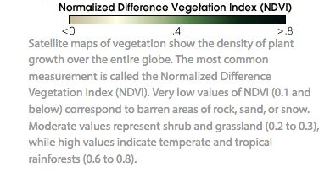

Data header (combined for all years 2000 – 2020) looks like:

X= longitude, Y=latitude, NDVI= value, Layer= Year. Has about 46,89,000 rows.

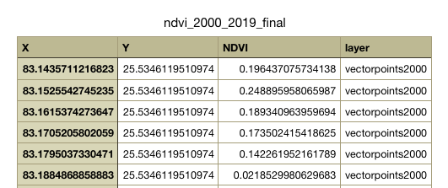

Our raster file looks like:

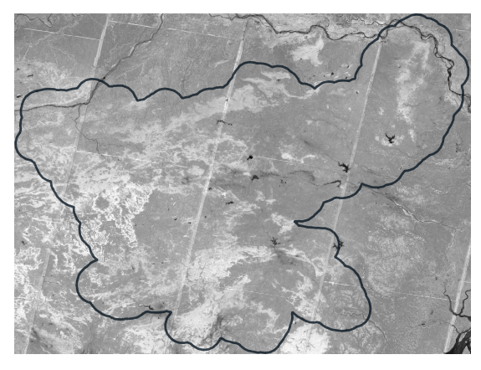

**Note:** The csv file exported contains every pixel value of every 1kmx1km pixel in the entire rectangle. When the .tif is clipped to jharkhand’s shapefile and vectorized into points (like below) and then exported into csv, somehow the latitude and longitude values are not retained. Therefore, all points in the rectangle above are saved in the csv file. For analysis, we can pick only those points that lie within the polygon.

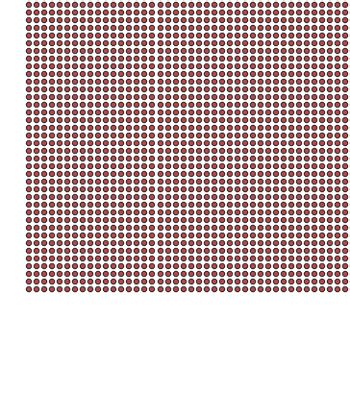 (one part of the vectorpoints file, magnified)

# **Land-cover types:**

MCD12Q1 International Geosphere-Biosphere Programme (IGBP) legend and class descriptions.

|  |  |  |
| --- | --- | --- |
| Name | Value | Description |
| Evergreen Needleleaf Forests | 1 | Dominated by evergreen conifer trees (canopy >2m). Tree cover >60%. |
| Evergreen Broadleaf Forests | 2 | Dominated by evergreen broadleaf and palmate trees (canopy >2m). Tree cover >60%. |
| Deciduous Needleleaf Forests | 3 | Dominated by deciduous needleleaf (larch) trees (canopy >2m). Tree cover >60%. |
| Deciduous Broadleaf Forests | 4 | Dominated by deciduous broadleaf trees (canopy >2m). Tree cover >60%. |
| Mixed Forests | 5 | Dominated by neither deciduous nor evergreen (40-60% of each) tree type (canopy >2m). Tree cover >60%. |
| Closed Shrublands | 6 | Dominated by woody perennials (1-2m height) >60% cover. |
| Open Shrublands | 7 | Dominated by woody perennials (1-2m height) 10-60% cover. |
| Woody Savannas | 8 | Tree cover 30-60% (canopy >2m). |
| Savannas | 9 | Tree cover 10-30% (canopy >2m). |
| Grasslands | 10 | Dominated by herbaceous annuals (<2m). |
| Permanent Wetlands | 11 | Permanently inundated lands with 30-60% water cover and >10% vegetated cover. |
| Croplands | 12 | At least 60% of area is cultivated cropland. |
| Urban and Built-up Lands | 13 | At least 30% impervious surface area including building materials, asphalt, and vehicles. |
| Cropland/Natural Vegetation Mo- saics | 14 | Mosaics of small-scale cultivation 40-60% with natural tree, shrub, or herbaceous vegetation. |
| Permanent Snow and Ice | 15 | At least 60% of area is covered by snow and ice for at least 10 months of the year. |
| Barren | 16 | At least 60% of area is non-vegetated barren (sand, rock, soil) areas with less than 10% vegetation. |
| Water Bodies | 17 | At least 60% of area is covered by permanent water bodies. |
| Unclassified | 255 | Has not received a map label because of missing inputs. |

Example from our dataset:

(random year chosen: 2008)

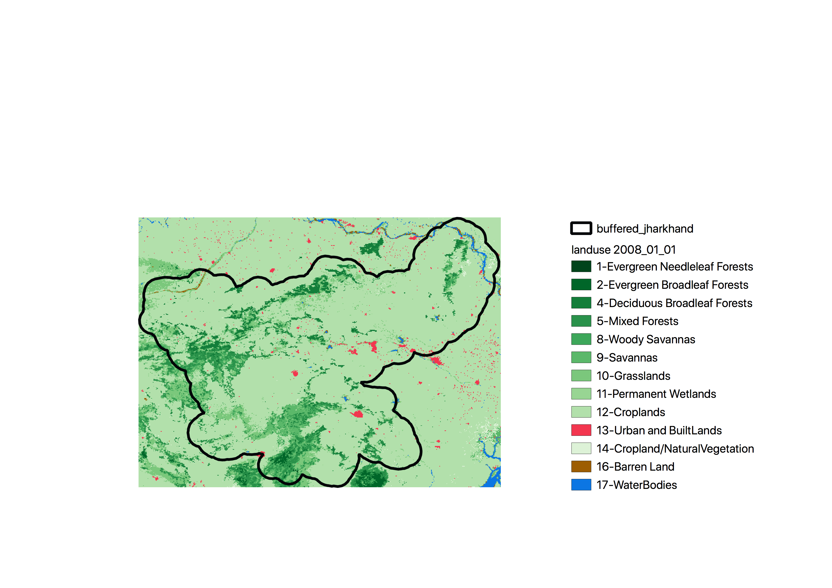

Data-header looks like:

X = longitude, Y=latitude, Land-Use-Type= value above, Layer=year. (this table can be pivoted to any shape we want)

Has about 35,00,0000 rows.

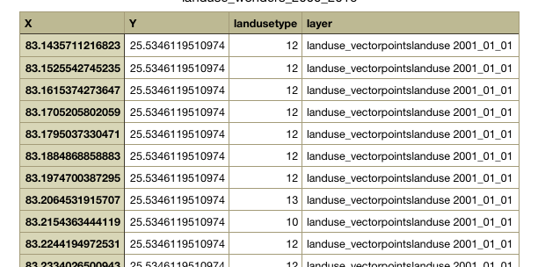

# **Giovanni**

Data points from Giovanni look like this:

Looking at a sample dataset of rainfall:

Rainfall: (for a particular year, 2000, in this case). The different csvs for each year can be merged together (they all have the same latitude and longitude sets)

Here, column1= longitude, column2=rainfall value,

